**Task 4 - Creating a Prototype User Interface and Usability Testing**

**Question 1:**

**How to ask questions in programming forum system**

**1)**

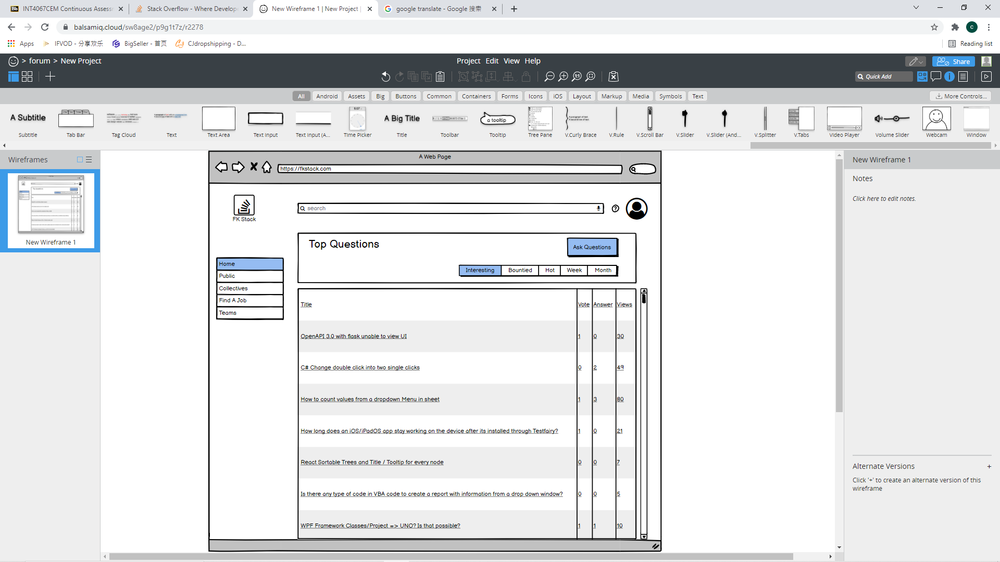

**2)**

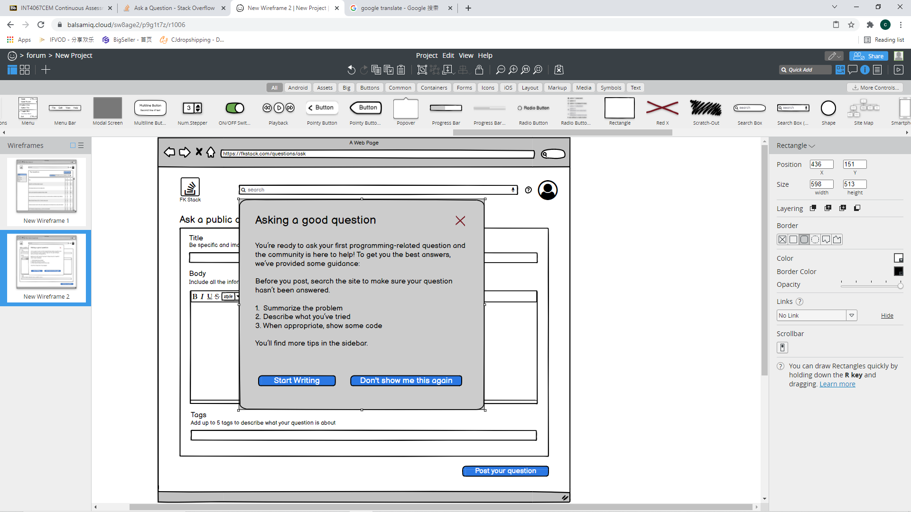

**3)**

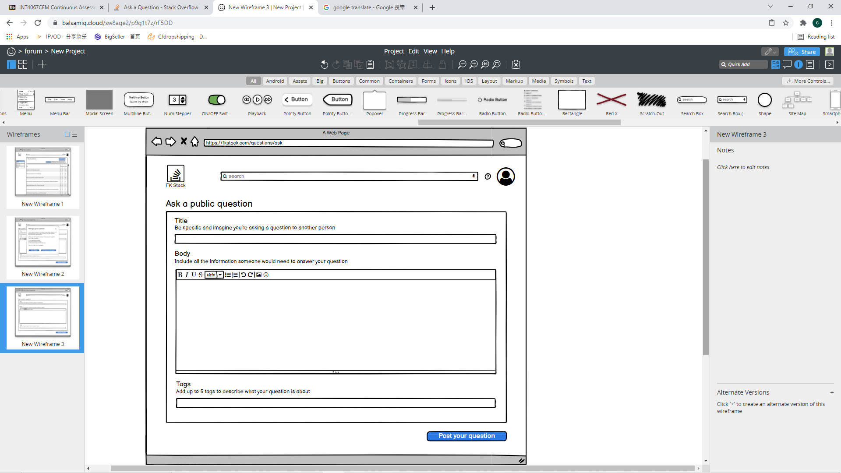

**Question 2: How to edit profile name**

**1)**

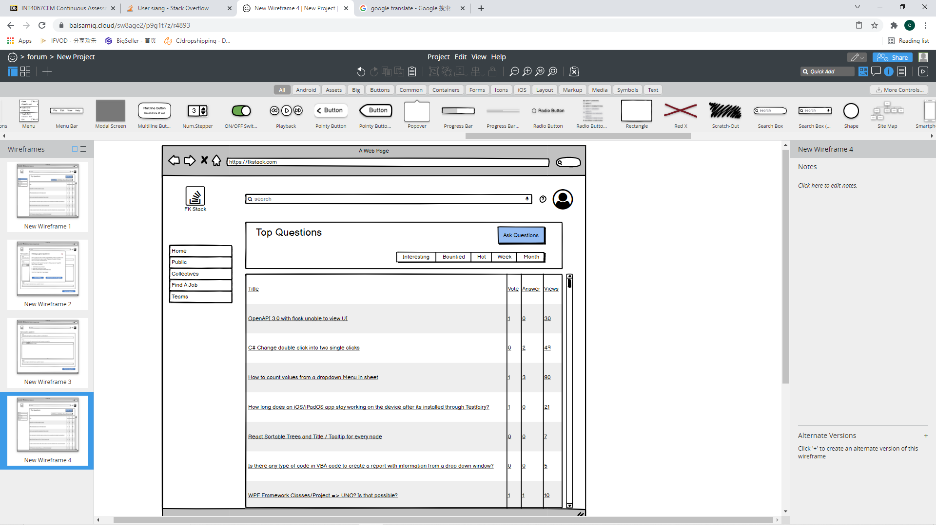

**2)**

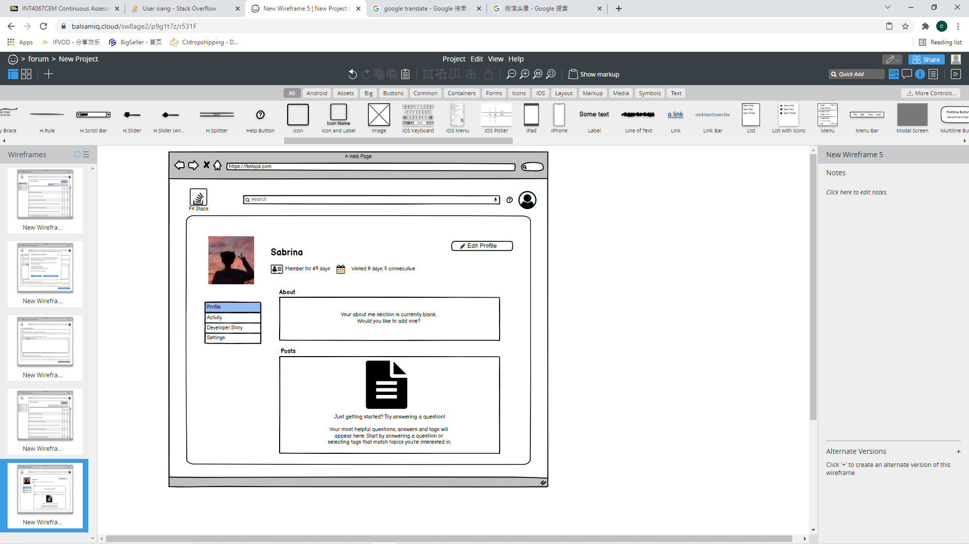

**3）**

